**Dental Clinic Services System**

Software Design

By

**Kanokwan Maneerat 542115002**

**Worapun Wongkium 542115055**

Department of Software Engineering

College of Arts, Media, and Technology

Chiang Mai University

Project Adviser

\_\_\_\_\_\_\_\_\_\_\_\_\_\_\_\_\_\_\_\_\_\_\_\_\_\_\_\_\_\_

Mrs. Yun Rim Park

**Software Design**

**Revision Table**

|  |  |  |  |  |  |
| --- | --- | --- | --- | --- | --- |
| **Document Name** | **Detail** | **Status** | **Date** | **Viewable** | **Reviewer& Responsible** |
| DCSS – SDD – v 0.1 | Add all document | Draft | 04/06/2014 | Adviser | Kanokwan & Worapun |
| DCSS – SDD – v 0.2 | Change class diagram and class diagram description | Draft | 10/06/2014 | Adviser | Kanokwan & Worapun |
| DCSS – SDD – v 0.3 | Edit class diagram and class diagram description | Draft | 27/06/2014 | Adviser | Kanokwan & Worapun |
| DCSS – SDD – v 0.4 | Edit class diagram, class diagram description, Sequence diagram | Draft | 07/06/2014 | Adviser | Kanokwan & Worapun |
| DCSS – SDD – v 0.5 | Edit class diagram, class diagram description, Sequence diagram | Draft | 07/06/2014 | Adviser | Kanokwan & Worapun |
| DCSS – SDD – v 0.6 | Double check all document | Draft | 07/06/2014 | Adviser | Kanokwan & Worapun |
| DCSS – SDD – v 0.7 | Edit sequence diagram | Draft | 07/15/2014 | Adviser | Kanokwan & Worapun |

Table of Contents

Chapter One: Introduction 4

1. Introduction 4

1.1 Objectives 4

1.2 Project Scope **ผิดพลาด! ไม่ได้กำหนดที่คั่นหน้า**

Chapter Two: Overall Description 7

2. Overall Description 7

2.1 Product Perspective 7

2.2 Product Features 7

2.3 Design and Implementation Constraints 7

Chapter Three: System Architecture 8

3. System Architecture 8

Chapter Four: Detail Design 10

4. Detail Design 10

4.1 Class diagram 10

Chapter Five: Sequence Diagram 27

5. Sequence Diagram 27

Chapter Six: User Interface Design 48

6. User Interface Design 49

# Chapter One: Introduction

## Introduction

### 1.1 Objectives

Dental clinic service system is a web application and mobile application, which support ios7. This application is support English language for the person who is the patient, the officer or the dentist of the dental clinic furthermore it allow visitor can use. This application will reduce officers’ work and do not waste patients’ time so, patient can find anything about dental clinic information or personal information and others from it. For the visitor who want to has a dental treatment from the clinic he/she can make an appointment to the dentist through the application and also the dentist can use it for checking patients’ schedule. The Dental clinic services system is gathered most of the services in the clinic into the web application and mobile application. When the application is grouping all the services together it will be uncomplicated for dental clinic user.

This Software Design has described in more detail of each designof system and each function flow that the system should do. The document includes the Scope of project, Product function, User characteristic, System architecture, Detail design, Sequence diagram, and User interface design.

### 1.2 Project Scope

The objective of this software requirement specification is to specify requirements to establish the application that:

* Dental clinic services system is a web application for both computers and mobile devices.
* Dental clinic services system for mobile devices supports iOS.
* Dental clinic services system supports English language only.
* Dental clinic services system provides for dental clinics’ registered user whose are patients, officers and dentists.
* Dental clinic services system provides the appointments of patients and dentists.
* Dental clinic services system provides user authentication for patients and dentists, which is maintained by dental clinic officers.

### 1.3 User Classes and Characteristics

The system divides users into 3 groups. Information and characteristics of each group are listed below.

* **Patient**

This group of users need to be registered to the system at the dental clinic. They will get patientID and password from the clinic to use the services on the website or using their mobile phone. Patients use their patientID to login. Patients are able to:

* Patient can receive the pateintID and password from the dental clinic.
* Patient can login to the website and the mobile application.
* Patient can logout from the website and mobile application.
* Patient can view his/her appointment in the patient schedule.
* Patient can view all appointments in the dental clinic schedule.
* **Officer**

This group of users have the highest privilege in the system. They are given access to management functions for maintaining the system. Officers are able to:

* Officer can login to the website by using userID and password.
* Officer can logout from the website.
* Officer can register for new patients and dentists.
* Officer can add an appointment into the dental clinic schedule.
* Officer can edit an appointment in the dental clinic schedule.
* Officer can delete an appointment in the dental clinic schedule.

**Dentist**

This group of users need to be registered to the system at the dental clinic. They will register their account at the clinic. Dentist use their userID and password to login to the system to use the services. Dentists are able to:

* Dentist can login to the website by using userID and password
* Dentist can logout from the website
* Dentist can view his/her appointment in the dentist schedule
* Dentist can view all appointment in the dental clinic schedule

**1.4 Operation Environment**

Dental clinic services system provides a web application and a mobile application for iOS. All users must have the Internet connection. Mobile devices must support iOS version 7.

**1.5 Acronyms and Definitions Acronyms**

|  |  |
| --- | --- |
| **Acronyms** | **Stands for** |
| Registered User | Patient, Dentist, and Officer |
| Non-registered User | Visitor |
| PM | Project Management |
| PMP | Project Management Plan |
| URS | User Requirement Specification |
| SRS | Software Requirement Specification |
| VSE | Very Small Entity |
| QR code | Quick Response Code |
| UC | Use Case |
| AD | Activity Diagram |
| UI | User Interface |
| UTC | Unit Test Case |
| STC | System Test Case |
| CD | Class Diagram |
| SD | Sequence Diagram |

# Chapter Two: Overall Description

## Overall Description

### 2.1 Product Perspective

The Dental clinic services system consists of a mobile application base on iOS and a web application. The system helps patients save their time to contact the dental clinic by providing features such as making an appointment, viewing upcoming appointment, and getting cost estimation. It helps dentist to follow up their patients and check their appointments and schedule. Also the system reduces works of officers by providing them with features such as using QR code to identify patients at the clinic, managing appointments for patients and dentists. This system combines most of dental clinics' services into one application.

### 2.2 Product Features

The dental clinic services system offers seven features.

* Feature 1: Schedule management
* Feature 2: User registration and authentication
* Feature 3: Appointment management
* Feature 4: Patient identification using QR code
* Feature 5: Dental care consulting and following up
* Feature 6: A dental clinic information and promotion
* Feature 7: Cost estimation of dental treatments

Each of features will create a step-by-step suit by priority. In this progress we will develop Feature 1, 2, and 3

### 2.3 Design and Implementation Constraints

### List of project constraints:

* The application works only on iOS version7.
* The application requires the Internet connection.
* The application is available for users who are already registered to the system to use all the services and who are not registered to the system will be a visitor whose can be able to use only some services.

# Chapter Three: System Architecture

## System Architecture

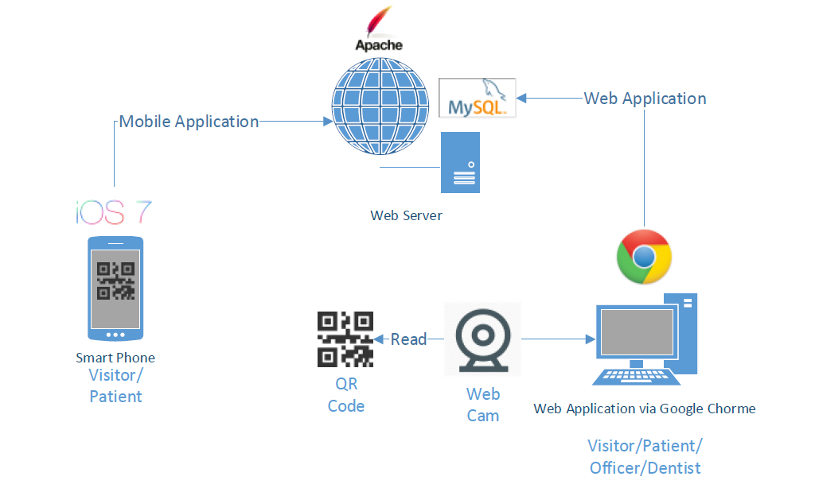

Figure 1: Shows the system architecture of Dental Clinic Services System

**Smart Phone:** This part will use Html language to create a hybrid mobile application from Phone Gap and PhoneGap Build. We design to create only a mobile application for iOS.User who not login to the system will call as a visitor. Visitor can view all appointment of the clinic, cost estimation, view promotion, dental clinic information and basic knowledge of dental treatment. User who uses the patientID and password to login will called patient, patient can view their appointment schedule and can receive QR Code for identifying themself at the clinic, consult with their dentist, and can use all services provided for visitor.

**QR Code:** QR Code uses to identified the patient at the clinic. The QR code contains the patientID for webcam to read QR Code.

**Web Cam:** Web cam is use to read the QR Code, and the system will check appointment and manage the queue for patient.

Web Application: Web application can be used by all type of user(patient, officer, and dentist). Patient can use all services in the web application as well as the mobile application. Officer can use web application to manage the appointment, dentist account, patient account, al so manage all the data in web application an mobile application such as can change the price in cost estimation function and change some information of dental clinic. dentist

**Web Server:** Web server is the server services provided for mobile application and web application link to each other with the same source of data and user.

# Chapter Four: Detail Design

## 4. Detail Design

### 4.1 Class diagram

**4.1.1 DCSS website class diagram**

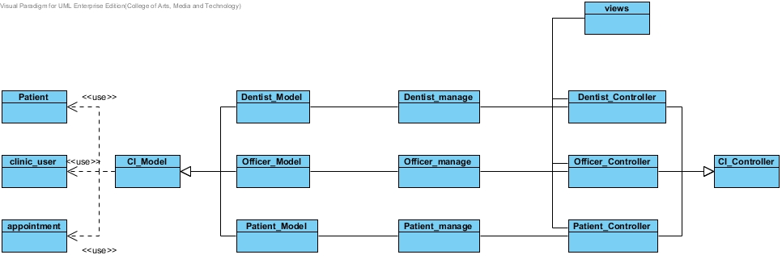

Figure 2: Shows class diagram of Dental Clinic Services System

**4.1.2 DCSS mobile application class diagram**

**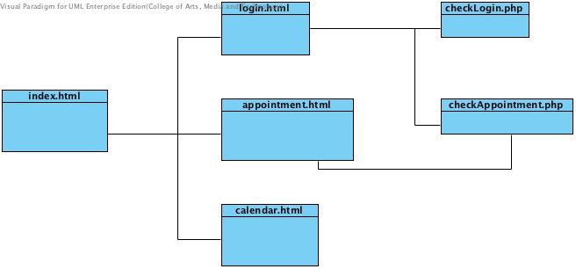**

Figure 3: Shows class diagram of Dental Clinic Services System in mobile application

4.2Class Diagram Description

4.2.1 Class Diagram Description (DCSS website)

CD-01, URS

Class name: clinic\_user

**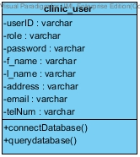**

Property

|  |  |  |  |
| --- | --- | --- | --- |
| ID | Name | Description | Remark |
| 1 | $userID | Identify the userID that store in the database. | Type: varchar |
| 2 | $role | Identify the users’ role such as dentist or officer that store in database | Type: varchar |
| 3 | $password | Identify the users’ password that store in database | Type: varchar |
| 4 | $f\_name | Identify the users’ firstname that store in the database. | Type: varchar |
| 5 | $l\_name | Identify the users’ surname that store in the database. | Type: varchar |
| 6 | $address | Identify the users’ address that store in the database. | Type: varchar |
| 7 | $email | Identify the users’ email that store in the database. | Type: varchar |
| 8 | $telNum | Identify the users’ telephone number that store in the database. | Type: varchar |

Method

|  |  |  |  |
| --- | --- | --- | --- |
| ID | Name | Description | Remark |
| 1 | connectDatabse() | Method uses to connect with the dental clinic database. | - |
| 2 | queryDatabase() | Method uses to query the data from the dental clinic database. | - |

CD-02,URS

Class name: Patient

**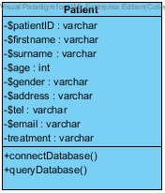**

Property

|  |  |  |  |
| --- | --- | --- | --- |
| ID | Name | Description | Remark |
| 1 | $patientID | Declare variable for identify the patientID that store in the database. | Type: varchar |
| 2 | $firstname | Declare variable for identify the patients’ firstname that store in the database. | Type: varchar |
| 3 | $surname | Declare variable for identify the patients’ surname that store in the database. | Type: varchar |
| 4 | $age | Declare variable for identify the patients’ age that store in the database. | Type: int |
| 5 | $gender | Declare variable for identify the patients’ gender that store in the database. | Type: varchar |
| 6 | $address | Declare variable for identify the patient’s address that store in the database. | Type: varchar |
| 7 | $tel | Declare variable for identify the patients’ tel that store in the database. | Type: varchar |
| 8 | $email | Declare variable for identify the patients’email that store in the database. | Type: varchar |
| 9 | $treatment | Declare variable for identify the patients’ dental treatment that store in the database. | Type: varchar |

Method

|  |  |  |  |
| --- | --- | --- | --- |
| ID | Name | Description | Remark |
| 1 | connectDatabse() | Method uses to connect with the dental clinic database. | - |
| 2 | queryDatabase() | Method uses to query the data from the dental clinic database. | - |

CD-03,URS

Class name: Patient\_Model

**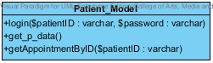**

Property

|  |  |  |  |
| --- | --- | --- | --- |
| ID | Name | Description | Remark |
| - | - | - | - |

Method

|  |  |  |  |
| --- | --- | --- | --- |
| ID | Name | Description | Remark |
| 1 | login($patientID:varchar,$password:varchar) | Method uses to login for patient. | - |
| 2 | get\_p\_data() | Method use to get the patients’ data from database | - |
| 3 | getAppointmentByID($patientID:varchar) | Method uses to get the appointments’ data from database | - |

CD-04,URS

Class name: Patient\_Controller

**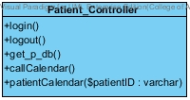**

Property

|  |  |  |  |
| --- | --- | --- | --- |
| ID | Name | Description | Remark |
| - | - | - | - |

Method

|  |  |  |  |
| --- | --- | --- | --- |
| ID | Name | Description | Remark |
| 1 | login() | Method uses to login for patient. | - |
| 2 | logout() | Method uses to logout for patient. | - |
| 3 | get\_p\_db() | Method uses to get patients’ data from database | - |
| 4 | callCalendar() | Method uses to call calendar page |  |
| 5 | patientCalendar() | Method uses to call their own calendar | - |

CD-05,URS

Class name: Officer

**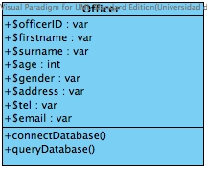**

Property

|  |  |  |  |
| --- | --- | --- | --- |
| ID | Name | Description | Remark |
| 1 | $officerID | Declare variable for identify the officerID that store in the database. | Type: varchar |
| 2 | $firstname | Declare variable for identify the officers’ firstname that store in the database. | Type: varchar |
| 3 | $surname | Declare variable for identify the officers’ surname that store in the database. | Type: varchar |
| 4 | $age | Declare variable for identify the officers’ age that store in the database. | Type: int |
| 5 | $gender | Declare variable for identify the officers’ gender that store in the database. | Type: varchar |
| 6 | $address | Declare variable for identify the officers’ address that store in the database. | Type: varchar |
| 7 | $tel | Declare variable for identify the officers’ tel that store in the database. | Type: varchar |
| 8 | $email | Declare variable for identify the officers’email that store in the database. | Type: varchar |

Method

|  |  |  |  |
| --- | --- | --- | --- |
| ID | Name | Description | Remark |
| 1 | connectDatabse() | Method uses to connect with the dental clinic database. | - |
| 2 | queryDatabase() | Method uses to query the data from the dental clinic database. | - |

CD-06,URS

Class name: Officer\_Model

****

Property

|  |  |  |  |
| --- | --- | --- | --- |
| ID | Name | Description | Remark |
| - | - | - | - |

Method

|  |  |  |  |
| --- | --- | --- | --- |
| ID | Name | Description | Remark |
| 1 | login($userID:varcahar) | Method uses to login for patient. | - |
| 2 | get\_db() | Method uses to get all dentists’ data and officers’ data from database | - |
| 3 | get\_p\_data() | Method uses to get all patients’ data from database | - |
| 4 | getDataByID($userID:varchar) | Method uses to get data of dentist by using userID | - |
| 4 | get\_p\_DataByID($pateintID:varchar) | Method uses to get data of patient by using patientID | - |
| 5 | addnew($data:array[]) | Method uses to add new patient to the database | - |
| 6 | update($data:array[]) | Method uses to update patients’ data to database | - |
| 8 | delete($patientID:varchar) | Method uses to delete patient from database by using of patientID | - |
| 9 | addnew\_d($data:array[]) | Method uses to add new dentist to the database | - |
| 10 | d\_update($data:array[]) | Method uses to update dentists’ data to database | - |
| 11 | get\_appointment() | Method uses to get data of appointments from database | - |
| 12 | make\_new($data:varchar) | Method uses to add new appointment to database | - |
| 13 | appointment\_update($data:varchar) | Method uses to update appointments’ data to database | - |
| 14 | app\_delete($appointmentID:int) | Method uses to delete appointments’ data from database | - |
| 15 | getAppointmentByID($patientID:varchar) | Method uses to get appointments’ data from database by using patientID | - |
| 16 | getAppointmentByUserID($userID:varchar) | Method uses to get appointments’ data from database by using userID | - |
| 17 | get\_p\_calendar() | Method uses to get all appointments’ data from database | - |
| 18 | get\_d\_calendar() | Method uses to get all appointments’ data from database | - |

CD-07,URS

Class name: Officer\_Controller

**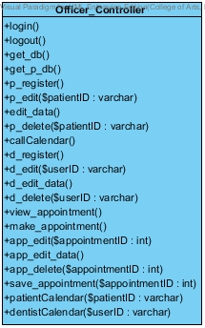**

Property

|  |  |  |  |
| --- | --- | --- | --- |
| ID | Name | Description | Remark |
| - | - | - | - |

Method

|  |  |  |  |
| --- | --- | --- | --- |
| ID | Name | Description | Remark |
| 1 | login() | Method uses to login for patient. | - |
| 2 | logout() | Method uses to logout for patient. | - |
| 3 | get\_db() | Method uses to get all dentists’ data and officers’ data from database | - |
| 4 | get\_p\_db() | Method uses to get all patients’ data from database. | - |
| 5 | p\_register() | Method uses to register new patient to the system | - |
| 6 | p\_edit($patientID:varchar) | Method uses to call patient edit page with appointment data | - |
| 7 | edit\_data() | Method uses to save the edit data of patient to the database | - |
| 8 | p\_delete($patientID:varchar) | Method uses to delete any patient from the system and database | - |
| 9 | callCalendar() | Method uses to call calendar from google calendar | - |
| 10 | d\_register() | Method uses to register new dentist to the system | - |
| 11 | d\_edit($userID:varchar) | Method uses to call dentist edit page with dentist data | - |
| 12 | d\_edit\_data() | Method uses to save the edit data of dentist to the database | - |
| 13 | d\_delete($userID:varchar) | Method uses to delete any dentist from the system and database | - |
| 14 | view\_appointment() | Method uses to get all appointment data to view | - |
| 15 | make\_appointment() | Method uses to make new appointment | - |
| 16 | app\_edit($appointment:varchar) | Method uses to call appointment edit page with appointment data | - |
| 17 | app\_edit\_data() | Method uses to save the edit data of appointment to the database | - |
| 18 | app\_delete($appointmentID:varchar) | Method uses to delete any appointment from the system and database | - |
| 19 | save\_appointment($appointmentID:varchar) | Method uses to save appointment to google calendar | - |
| 20 | patientCalendar($patientID:varchar) | Method uses to get patients’ calendar by using patientID | - |
| 21 | dentistCalendar($userID:varchar) | Method uses to get dentists’ calendar by using userID | - |

CD-08,URS

Class name: Dentist

**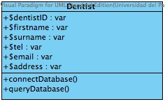**

Property

|  |  |  |  |
| --- | --- | --- | --- |
| ID | Name | Description | Remark |
| 1 | $dentistID | Declare variable for identify the dentistID that store in the database. | Type: varchar |
| 2 | $firstname | Declare variable for identify the dentists’ firstname that store in the database. | Type: varchar |
| 3 | $surname | Declare variable for identify the dentists’ surname that store in the database. | Type: varchar |
| 4 | $address | Declare variable for identify the dentists’ address that store in the database. | Type: varchar |
| 5 | $tel | Declare variable for identify the dentists’ tel that store in the database. | Type: varchar |
| 6 | $email | Declare variable for identify the dentists’email that store in the database. | Type: varchar |

Method

|  |  |  |  |
| --- | --- | --- | --- |
| ID | Name | Description | Remark |
| 1 | connectDatabse() | Method uses to connect with the dental clinic database. | - |
| 2 | queryDatabase() | Method uses to query the data from the dental clinic database. | - |

CD-9,URS

Class name: Dentist\_Model

**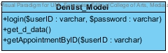**

Property

|  |  |  |  |
| --- | --- | --- | --- |
| ID | Name | Description | Remark |
| - | - | - | - |

Method

|  |  |  |  |
| --- | --- | --- | --- |
| ID | Name | Description | Remark |
| 1 | login($userID:varchar,$password:varchar) | Method uses to login for dentist. | - |
| 2 | get\_d\_data() | Method uses to get dentist data from database | - |
| 3 | getAppointmentByID($userID:varchar) | Method uses to get appointment by using userID | - |

CD-10,URS

Class name: Dentist\_Controller

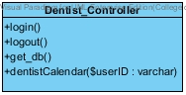

Property

|  |  |  |  |
| --- | --- | --- | --- |
| ID | Name | Description | Remark |
| - | - | - | - |

Method

|  |  |  |  |
| --- | --- | --- | --- |
| ID | Name | Description | Remark |
| 1 | login() | Method uses to login for dentist. | - |
| 2 | logout() | Method uses to logout for dentist. | - |
| 3 | get\_db() | Method uses to get dentist data from database | - |
| 4 | dentistCalendar($userID:varchar) | Method uses to get dentist calendar by userID | - |

CD-11,URS

Class name: Patient manage

**C:\Users\SONY\Desktop\senior project\progress1\usecase\cd.jpg\patient_manage.jpg**

Property

|  |  |  |  |
| --- | --- | --- | --- |
| ID | Name | Description | Remark |
| - | - | - | - |

Method

|  |  |  |  |
| --- | --- | --- | --- |
| ID | Name | Description | Remark |
| 1 | login($patientID:varchar,$password:varchar) | Method uses to login for patient. | - |
| 2 | getCalendarByPID($patientID:varchar) | Method uses to get patients’ calendar by using patientID | - |

CD-12,URS

Class name: Officer manage

**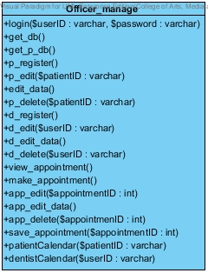**

Property

|  |  |  |  |
| --- | --- | --- | --- |
| ID | Name | Description | Remark |
| - | - | - | - |

Method

|  |  |  |  |
| --- | --- | --- | --- |
| ID | Name | Description | Remark |
| 1 | login($userID:varcahar) | Method uses to login for patient. | - |
| 2 | get\_db() | Method uses to get all dentists’ data and officers’ data from database | - |
| 3 | get\_p\_data() | Method uses to get all patients’ data from database | - |
| 4 | getDataByID($userID:varchar) | Method uses to get data of dentist by using userID | - |
| 4 | get\_p\_DataByID($pateintID:varchar) | Method uses to get data of patient by using patientID | - |
| 5 | addnew($data:array[]) | Method uses to add new patient to the database | - |
| 6 | update($data:array[]) | Method uses to update patients’ data to database | - |
| 8 | delete($patientID:varchar) | Method uses to delete patient from database by using of patientID | - |
| 9 | addnew\_d($data:array[]) | Method uses to add new dentist to the database | - |
| 10 | d\_update($data:array[]) | Method uses to update dentists’ data to database | - |
| 11 | get\_appointment() | Method uses to get data of appointments from database | - |
| 12 | make\_new($data:varchar) | Method uses to add new appointment to database | - |
| 13 | appointment\_update($data:varchar) | Method uses to update appointments’ data to database | - |
| 14 | app\_delete($appointmentID:int) | Method uses to delete appointments’ data from database | - |
| 15 | getAppointmentByID($patientID:varchar) | Method uses to get appointments’ data from database by using patientID | - |
| 16 | getAppointmentByUserID($userID:varchar) | Method uses to get appointments’ data from database by using userID | - |
| 17 | get\_p\_calendar() | Method uses to get all appointments’ data from database | - |
| 18 | get\_d\_calendar() | Method uses to get all appointments’ data from database | - |

CD-13,URS

Class name: Dentist manage

**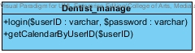**

Property

|  |  |  |  |
| --- | --- | --- | --- |
| ID | Name | Description | Remark |
| - | - | - | - |

Method

|  |  |  |  |
| --- | --- | --- | --- |
| ID | Name | Description | Remark |
| 1 | login($patientID:varchar,$password:varchar) | Method uses to login for patient. | - |
| 2 | getCalendarByUserID($patientID:varchar) | Method uses to get dentists’ calendar by using dentistID | - |

# 

# Chapter Five: Sequence Diagram

## 5. Sequence Diagram

**5.1 DCSS website Sequence Diagram**

**SD-01: Login**

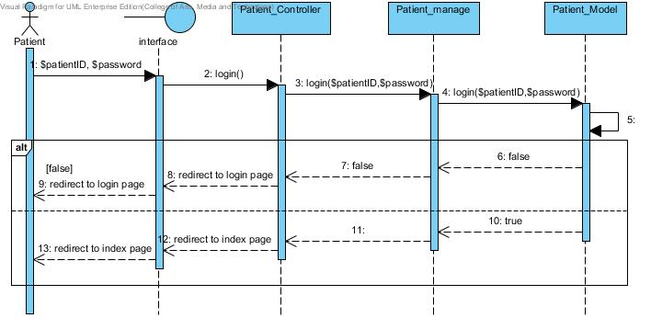

Figure 4: Patient Login

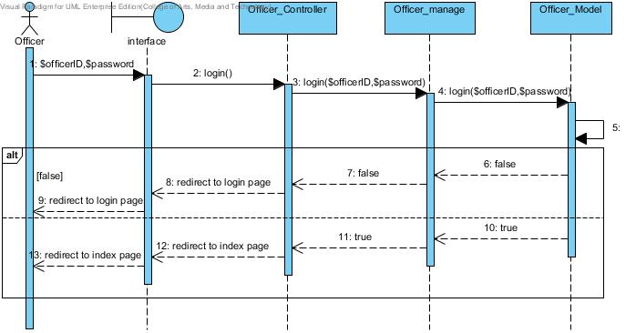

Figure 5: Officer Login

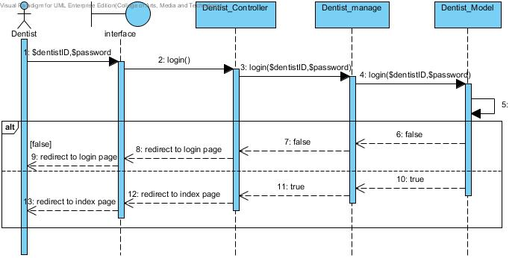

Figure 6: Dentist login

**SD-02: Logout**

**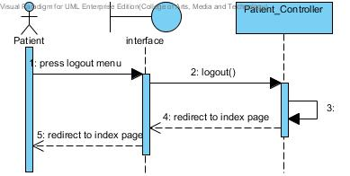**

Figure 7: Patient logout

**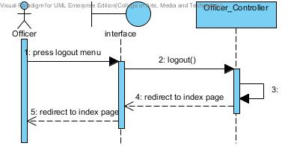**

Figure 8: Officer logout

**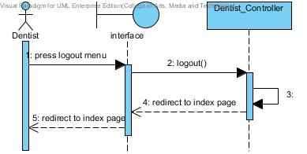**

Figure 9: Dentist Logout

**SD-03: View dental clinic calendar**

**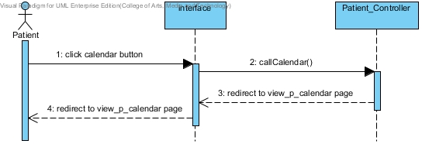**

Figure 10: Patient view dental clinic calendar

**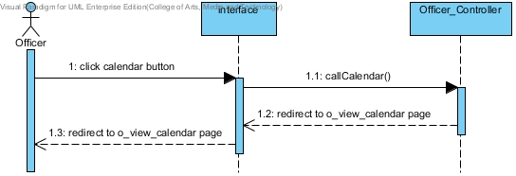**

Figure 11: Officer view dental clinic calendar

**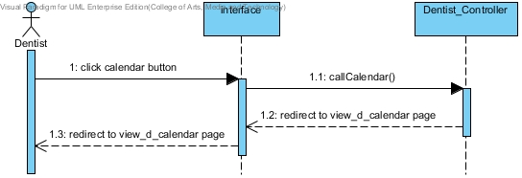**

Figure 12: Dentist view dental clinic calendar

**SD-04: View his/her own appointment**

**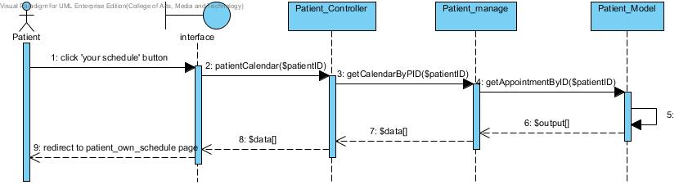**

Figure 13: Patient can view his/her own appointment

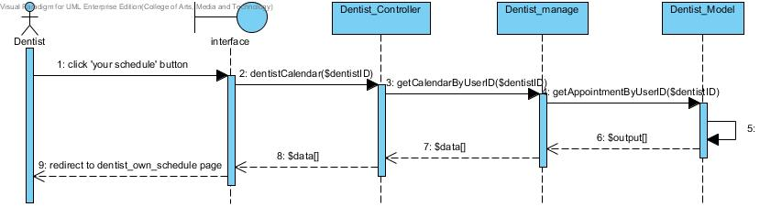

Figure 14: Dentist can view his/her own appointment

**SD-05: View all appointment in dental clinic**

**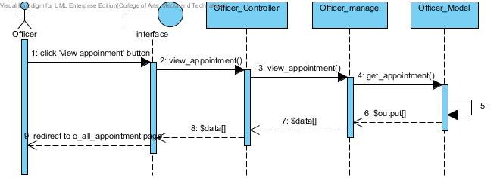**

Figure 15:Officer can view all appointment in dental clinic

**SD-06:Create patient account**

**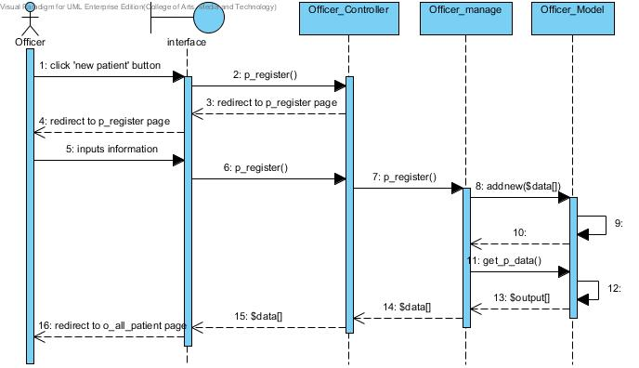**

Figure 16: Officer can create new patient account and the list of all patients show after register.

**SD-07: Create dentist account**

**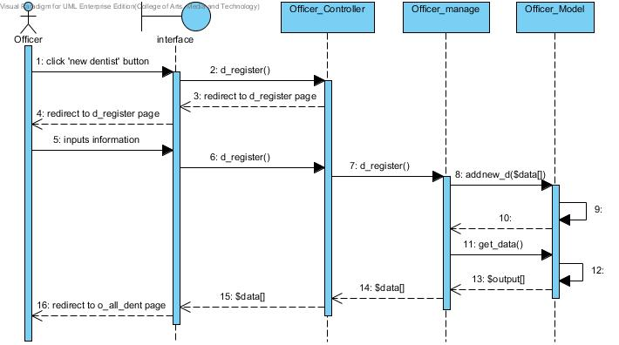**

Figure 17: Officer can create new dentist account and the list of all clinic user shows after register

**SD-08: View all patients as a list**

**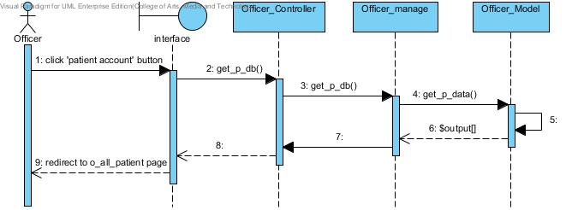**

Figure 18: Officer can view all patients as a list

**SD-09: View all dentist as a list**

**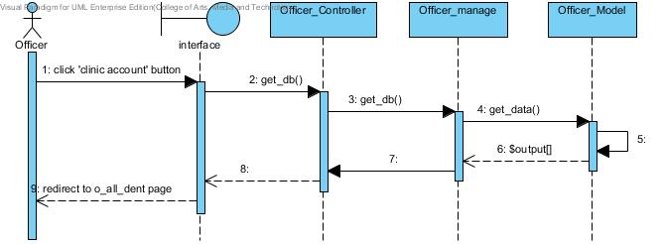**

Figure 19: Officer can view all dentists in the list

**SD-10: Make an appointment**

**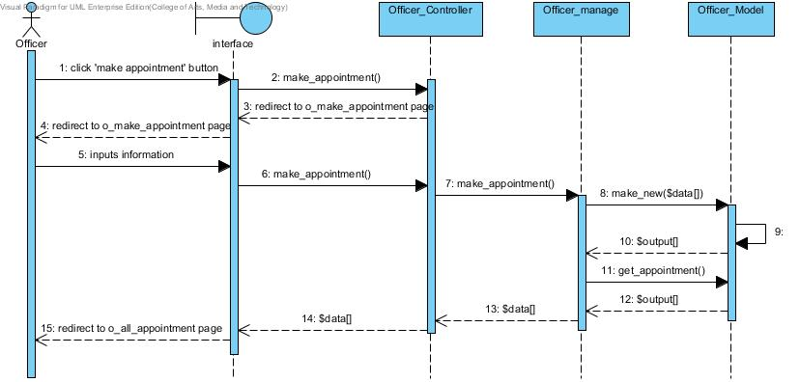**

Figure 20: Officer can add new appointment into the database and it will update in the dental clinic appointment schedule

**SD-11: Edit an appointment**

**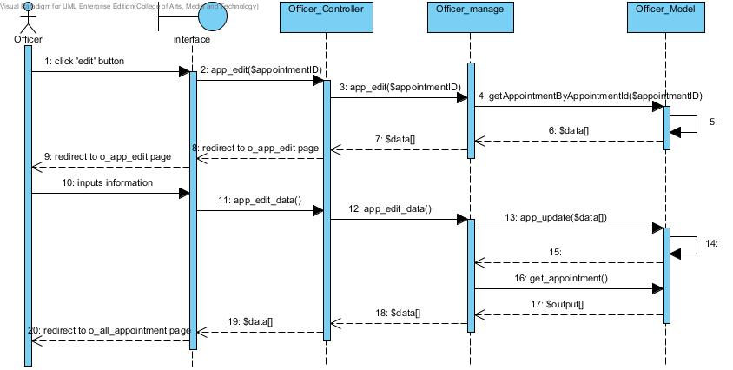**

Figure 21: Officer can edit an appointment into the database and it will update in the dental clinic appointment schedule

**SD-12: Delete an appointment**

**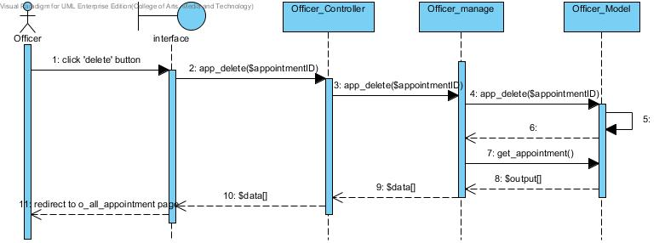**

Figure 22: Officer can delete an appointment into the database and it will update in the dental clinic appointment schedule

**SD-13: Edit patients’ account**

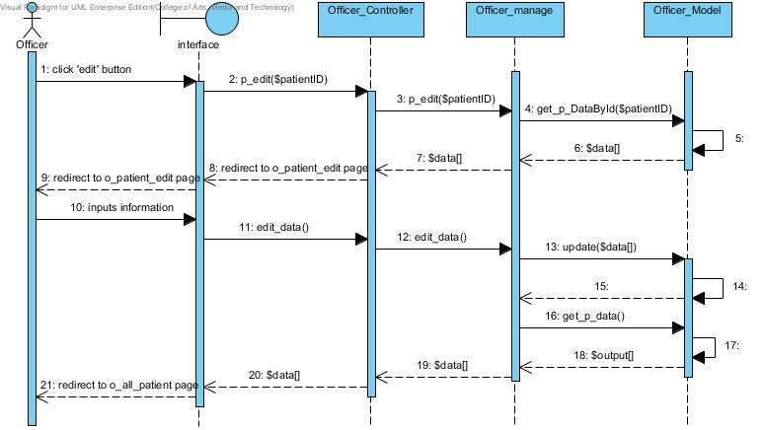

Figure 23: Officer can edit patients’ account and the list of all patients shows after edit

**SD-14: Edit dentists’ account**

**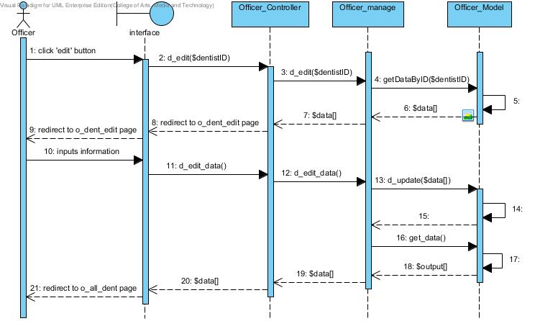**

Figure 24: Officer can edit dentists’ account and the list of all clinic users shows after edit

**SD-15: Delete patients’ account**

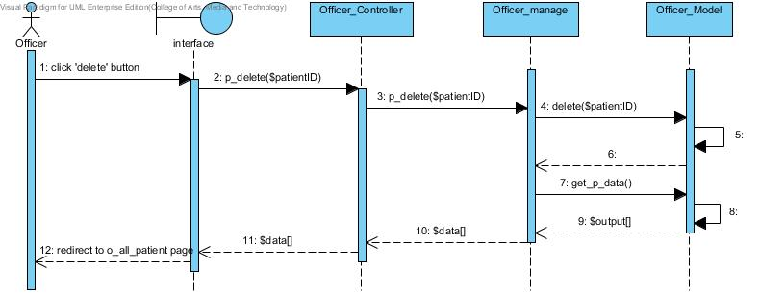

Figure 25: Officer can delete patients’ account and the list of all patients shows after edit

**SD-16: Delete dentists’ account**

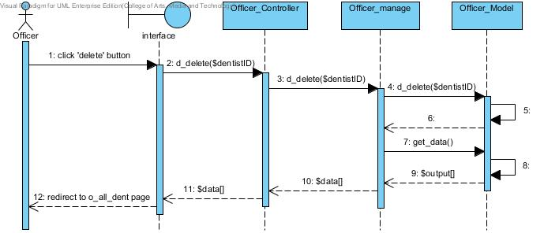

Figure 26: Officer can delete dentists’ account and the list of all dentists shows after edit

**SD-17: Save appointment to Google Calendar**

**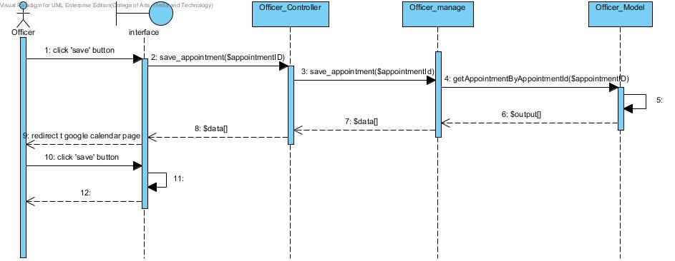**

Figure 27: Officer can save an appointment to Google Calendar by using dental clinic services system Google account

**5.2 DCSS mobile application Sequence Diagram**

**SD-18: Login to the mobile application**

**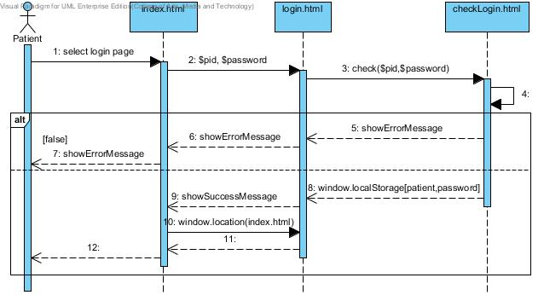**

Figure 28: Patient can login to the mobile application

**SD-19: View his/her own appointment**

**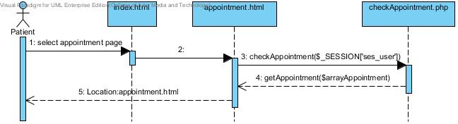**

Figure 29: Patient can view his/her appointment after login if user does not login the appointment will not diaplay

**SD-20: View appointment in Google calendar**

**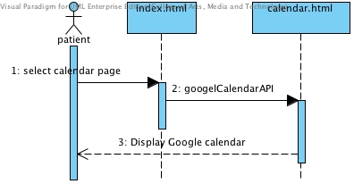**

Figure 30: Patient can view all appointment in google calendar

**SD-21: Logout from mobile application**

**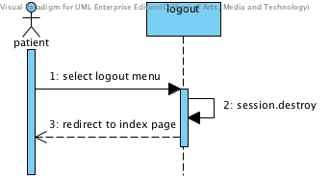**

Figure 31: Patient logout from mobile application

# Chapter Six: Database Design

## 6. Database Design

**6.1 Database design**

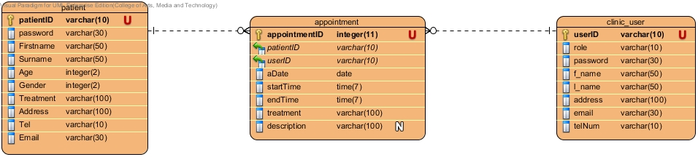

Figure 32: Database design of Dental Clinic Services System

# Chapter Seven: User Interface Design

## 7. User Interface Design

**7.1 Web design**

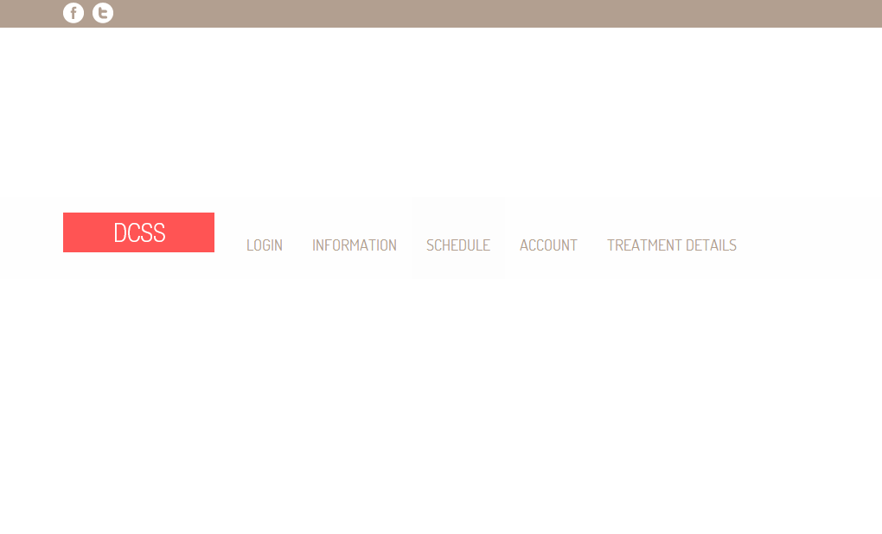

Figure 33: Shows the index page of website[UI-01]

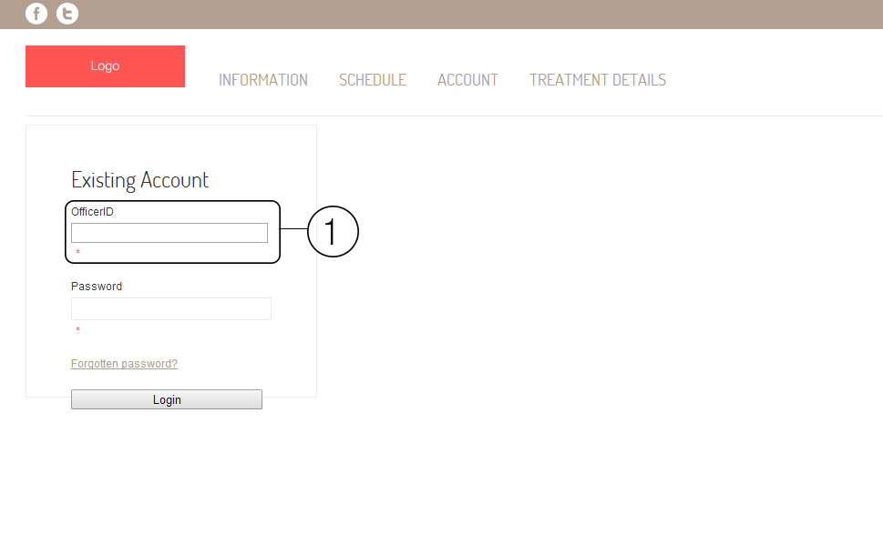

Figure 34: Shows the login page of the website. The area number 1 is the field of input userID and patientID. In officer login page will show as OfficerID, in patient login page will show as PatientID, and in dentist login page will show as DentistID.[UI-02]

**Patient**

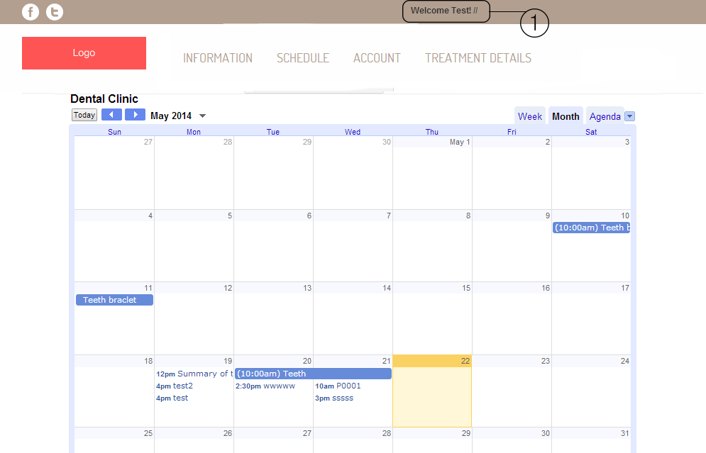

Figure 35: Shows the schedule of dental clinic from google calendar. The area number 1 will shows the name of patient.[UI-03]

**Officer**

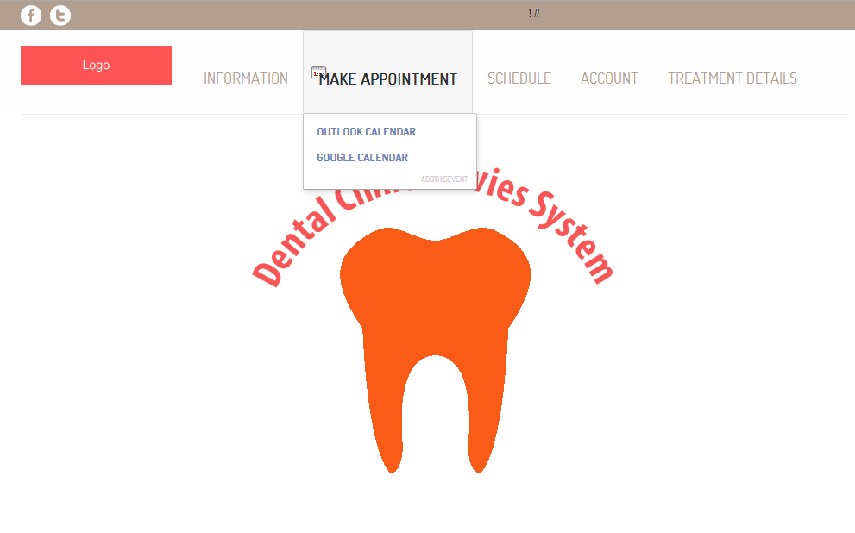

Figure 36: Shows the officer index page after officer login. Officer can make appointment google calendar, view schedule, and manage account.[UI-04]

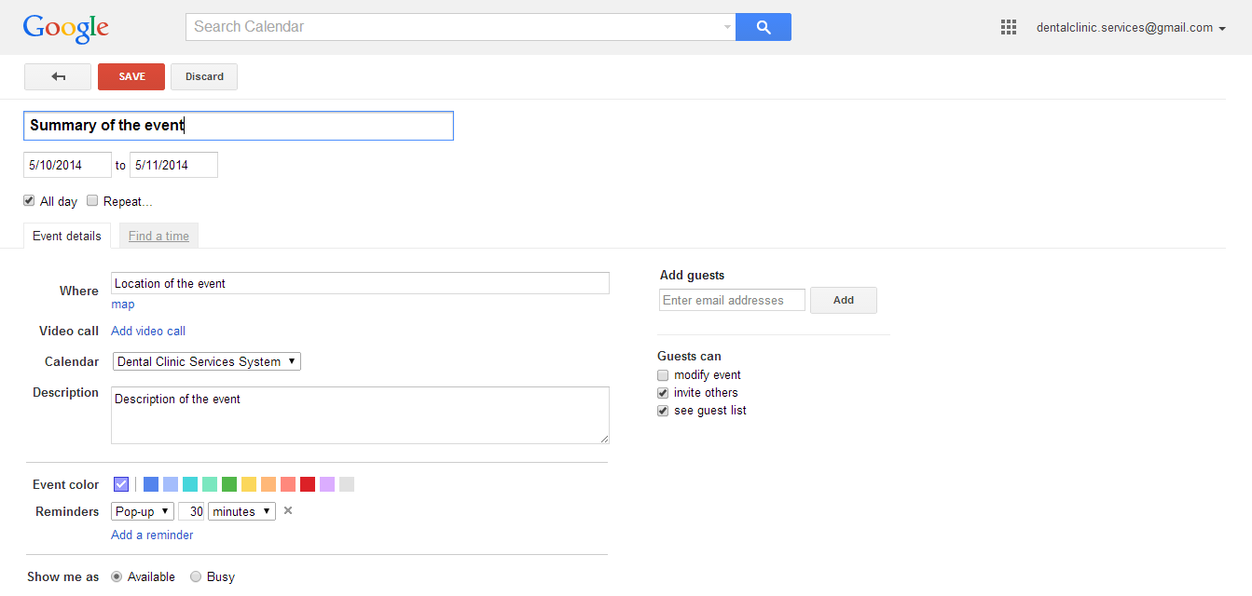

Figure 37: Shows page of google calendar to add the appointment to dental clinic calendar.[UI-05]

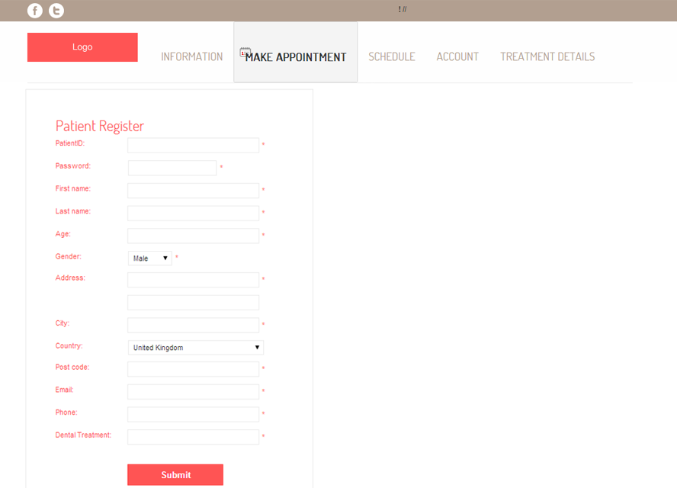

Figure 38: Shows the patient registration page.[UI-06]

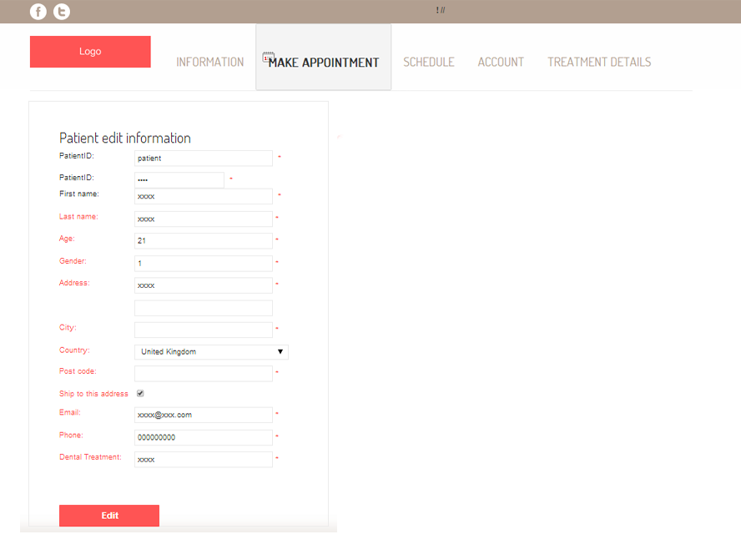

Figure 39: Shows the edit patients’ details page.[UI-07]

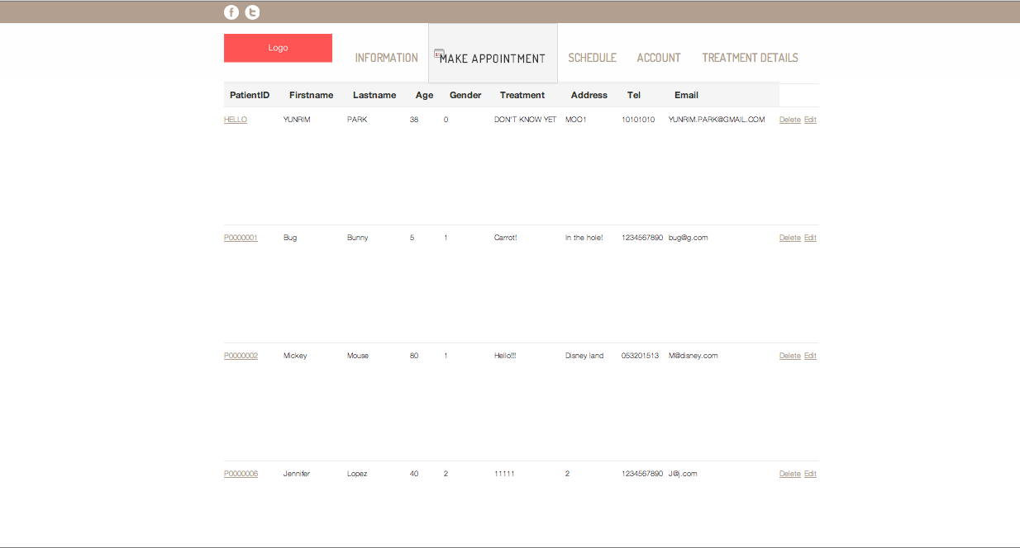

Figure 40: Shows patient list. [UI-08]

Figure 41: Create dentists’ account. [UI-09]**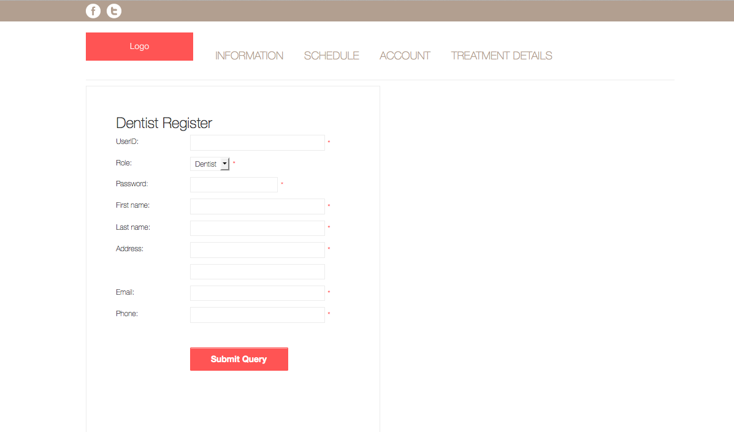**

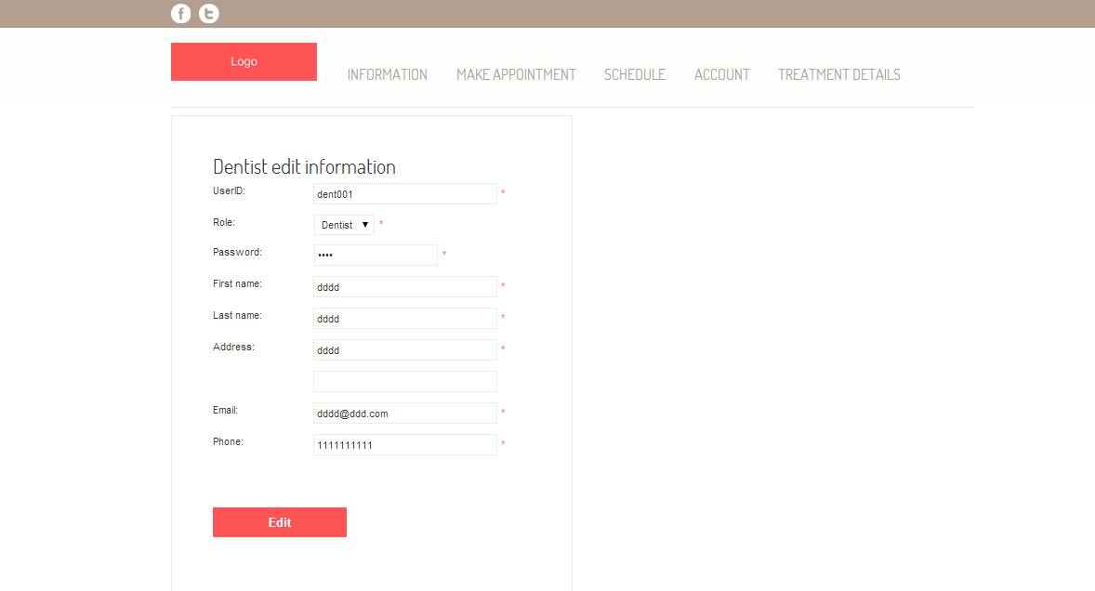Figure 42: Dentist edit information page[UI-10].

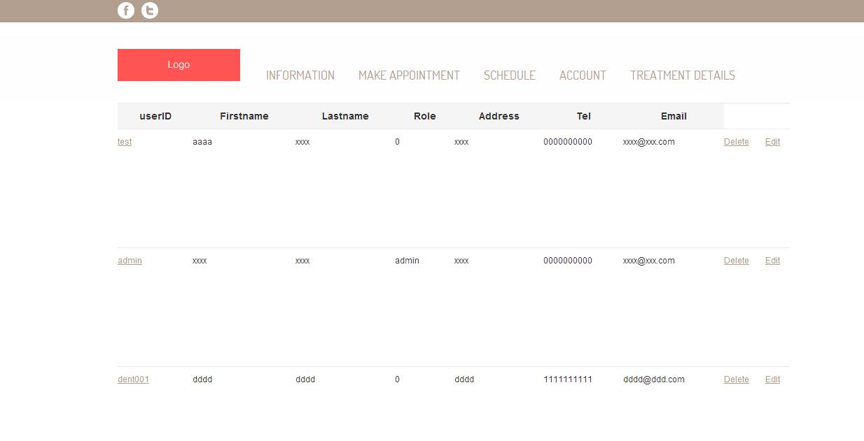

Figure 43: Dentist list page[UI-11].

**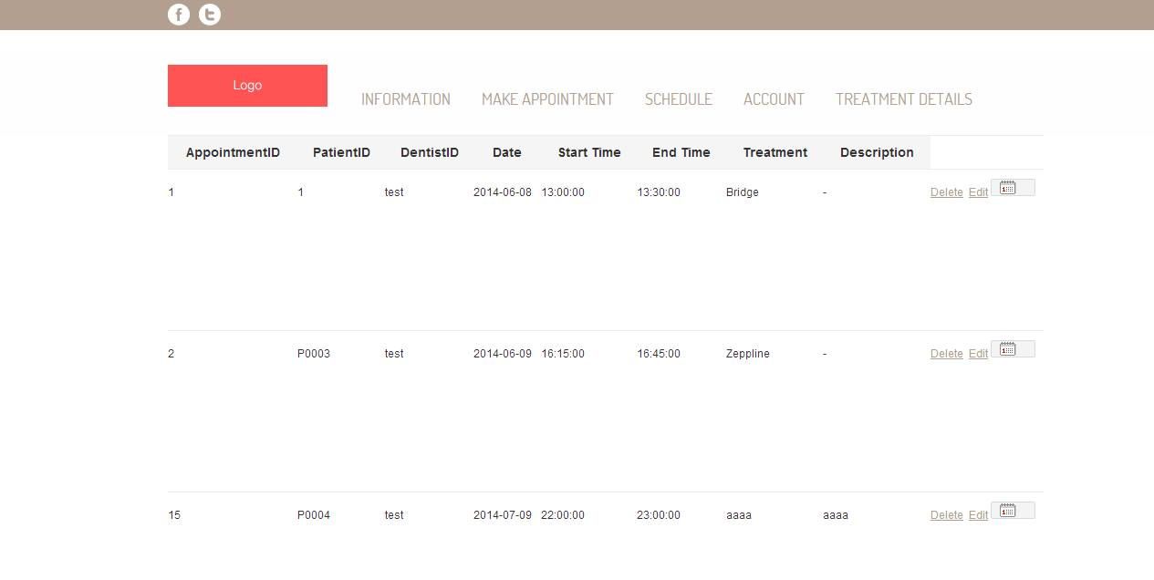**

Figure 44: Show appointment list[UI-12].

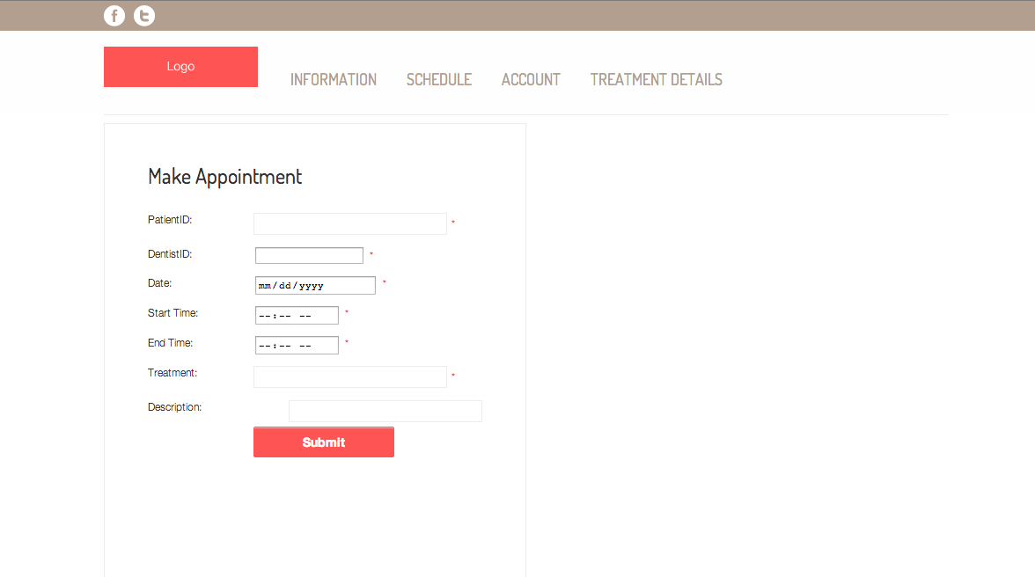

Figure 45: Create appointment page[UI-13].

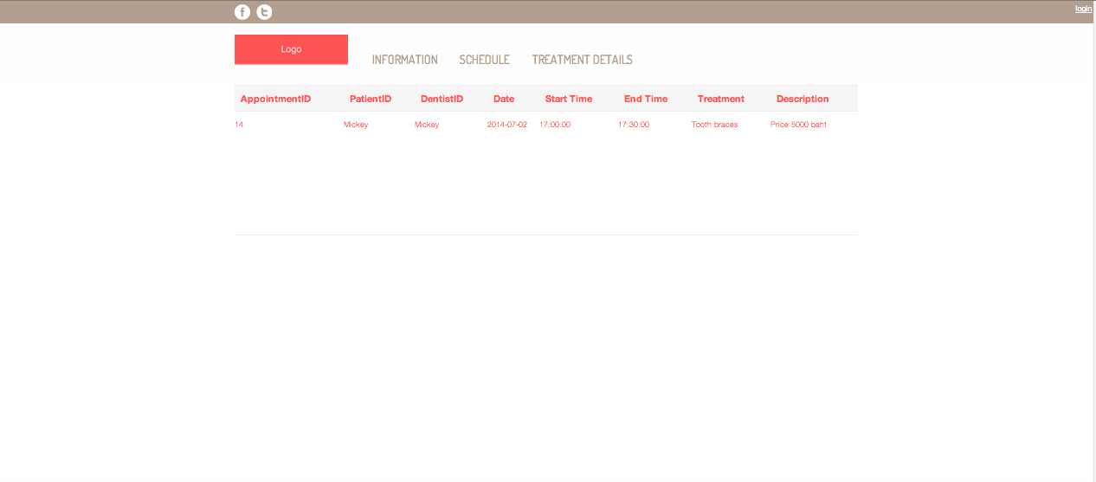

Figure 46: Show patients’ own appointment[UI-14].

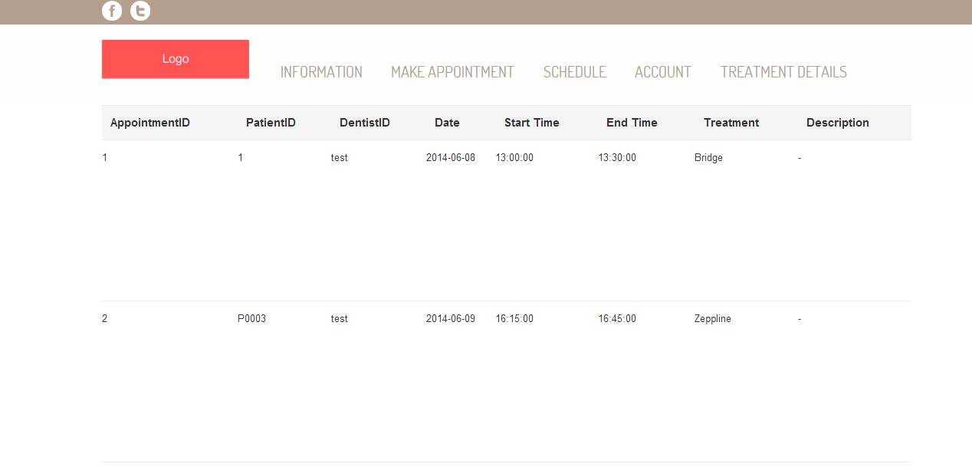

Figure 47: Show dentists’ own appointment[UI-15].

**6.2Mobile application design**

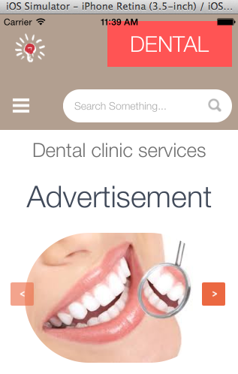

Figure 48: Mobile application index page[UI-16]

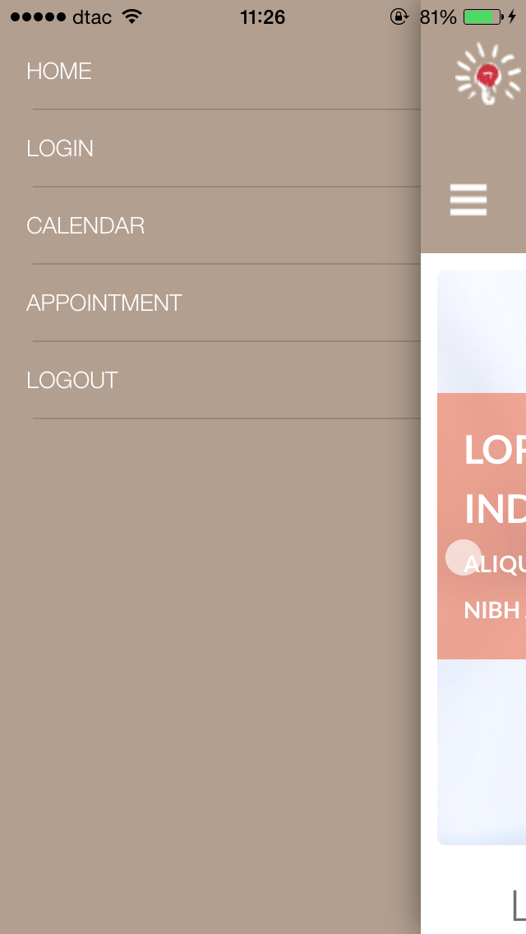

Figure 49: Mobile application menu [UI-17]

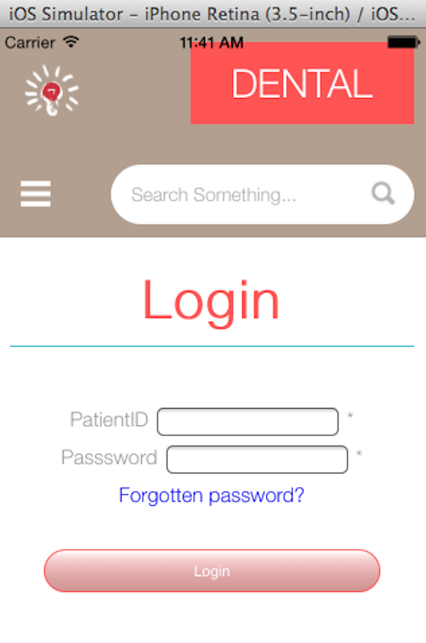

Figure 50: Login page for patient [UI-18]

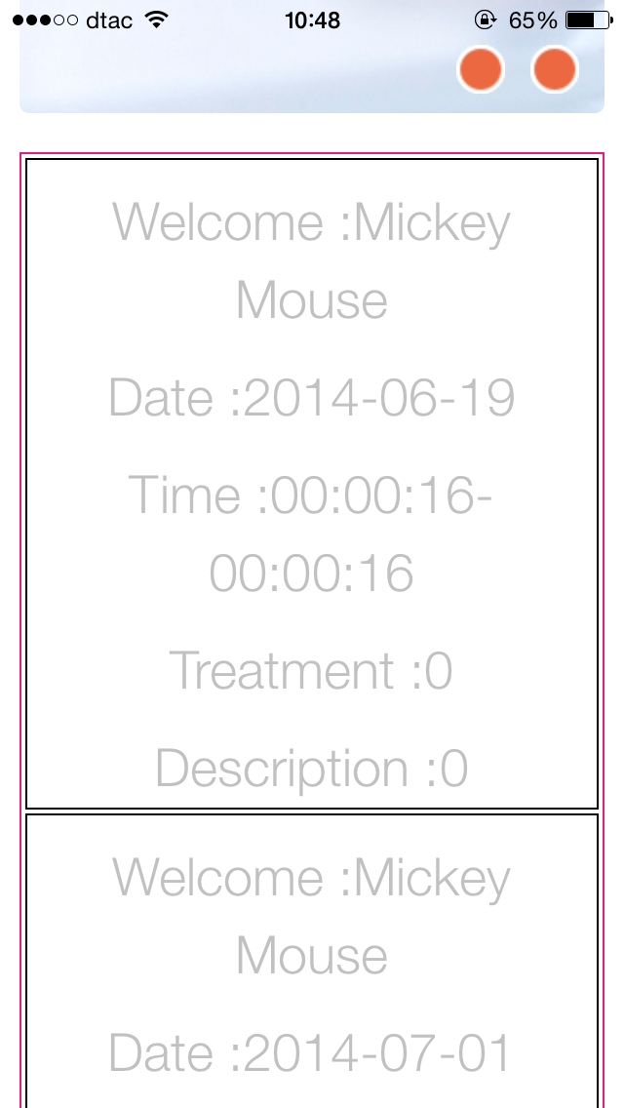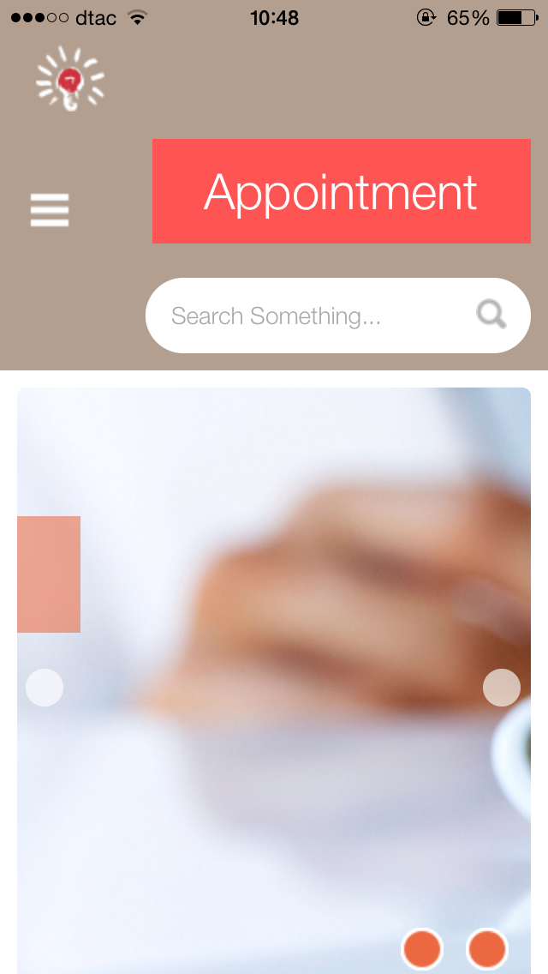

Figure 51: Display patients’ appointment [UI-19]

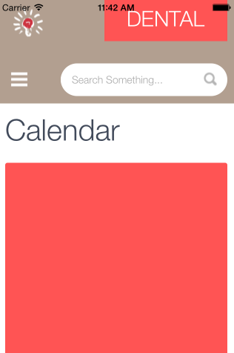

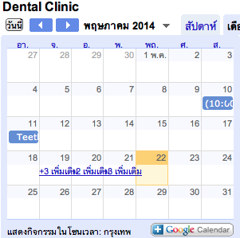

Figure 52: Dental clinic calendar [UI-20]